
GENG4412
Engineering Research Project Part 2

23398223
Jared
Healy

GENG4412/5512: Development of JavaScript based web system for displaying operational ocean - atmosphere model results.
Jared Healy (23398223)

Project Type: Design and Build

Updated Problem Statement
This project aims to take for atmospheric and oceanic forecast data and render it in an accessible and visualisable manner through the browser.

Progress to Date
The progress of this project has been strong but is still not completely on target. One major chang that has happened during the tenure of the project was the shift away from kano. The documentation for kano and the associated software stack (kargo, krawler and Weacast) is incredibly sparse, and the documentation that does exist is often outdated and lacking in detail (to the point where Docker Swarm, the virtualisation software which kargo’s documentation says to use, has not been used by the software since 2022). As a result of this, the frontend for the visualisation has been built on the back of leaflet directly. The rendering is split into two major parts: the parts rendered using dynamically generated SVG’s (Scalable Vector Graphics), and the particle visualisation, which is rendered using the leaflet velocity library (Leaflet Velocity, 2017).

The SVG graphics which have been generated have been used to check correctness against a known source, which renders data using wind barbs. These are generated at runtime by taking the speed of the wind in knots, rounding it to the nearest five and then using that value to create the necessary tails. They currently do not account for the pennants required for windspeeds over 50kt. As well as the barbs, there are SVG graphics used to render the average value over an area and show that velocity in colour.
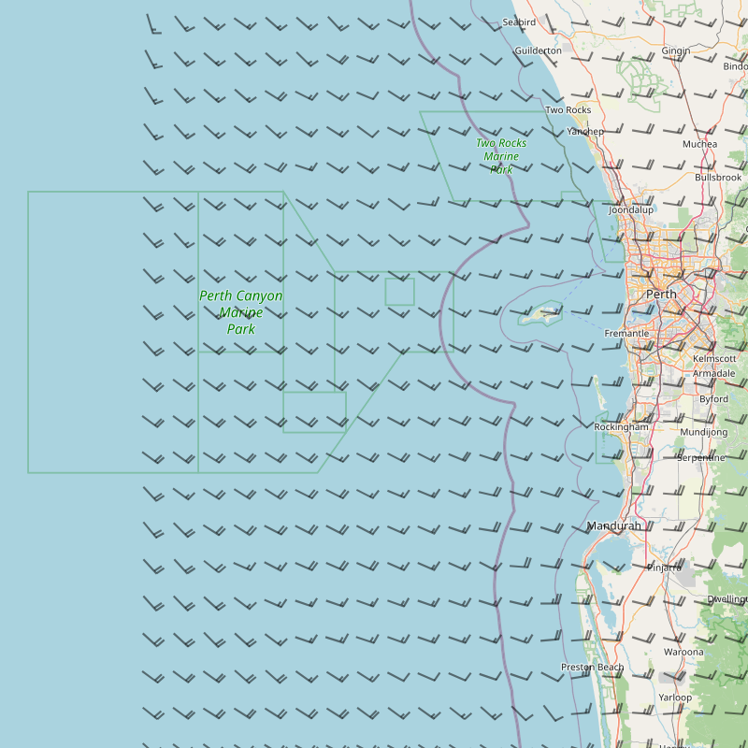Figure 1: The wind barbs being rendered on the street map view
The particle rendering for the project is done using leaflet-velocity, a leaflet plugin which is a port of the rendering software ‘earth’ (cambecc, 2013). The visualiser takes data in the form of a JSONified GRIB file and renders the data to the map as below. The implementation of leaflet-velocity into this project has faced some challenges due to the project using react-leaflet instead of pure JavaScript, and, although it is functional, probably requires a re-visit in the near future.
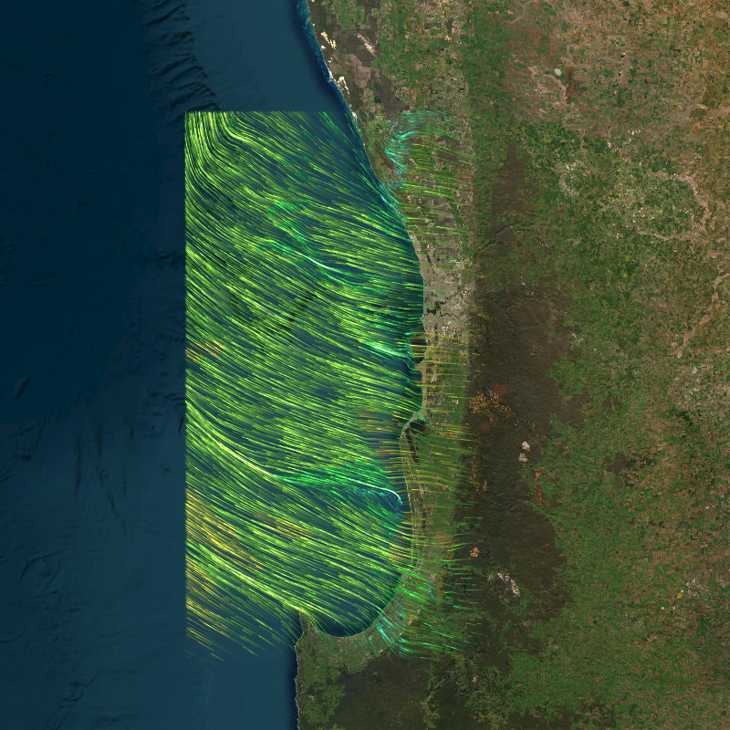Figure 2: The particle simulation being rendered on the satellite view
Some of the more minor features include a way to get values from specific coordinates using the tooltip feature of leaflet, as well as a playback bar which allows you to browse the weather at different times.

Remaining Tasks and Timeline
There are still many tasks which lay ahead in this project. One of the main tasks is to convert the data from being read from GRIB files to reading from the OPeNDAP server, which will be done through jsDAP (stcorp, 2006). The biggest challenge in pulling data from the OPeNDAP server is automatically grabbing the most up-to-date files or, alternatively, getting the catalogue such that the user can select the forecast they wish to view.

Another challenge is the visualisation of other forms of data. Implementing a visualisation of the ocean data will be done using the same techniques as the wind data, mapping to both arrows and a particle simulation using leaflet velocity.
The project also still requires Dockerisation, which is how the program is to be deployed. Dockerising, while not difficult, is probably of high priority, so that testing in the production environment is possible and any unexpected difficulties can be managed.

Another feature which may be implemented provided there is adequate time is an ability to graph the weather data at specific points over time, to see how trends effect specific areas.

Risk management
The key risks to delivery of this project at this point mainly revolve around the technical limitations of jsDAP, as well as the OPeNDAP server itself. If there are major issues with receiving the data from the server, or the data doesn’t behave nicely with the rendering stack which has been developed to this point, then there could be issues. However, these issues seem unlikely, as even a cursory investigation of the data at the relevant server shows useful relevant data in the ‘WRF 9km/2km CWA/PERTH model outputs and 2026 year’. The only remaining concern that this project faces is the possible difficulty of obtaining the catalogue for the data.

References

cambecc. (2013, 11 04). Earth. Retrieved from Github: https://github.com/cambecc/earth
Leaflet Velocity. (2017, 02 6). Retrieved from Github: https://github.com/onaci/leaflet-velocity
stcorp. (2006, 07 28). jsDAP. Retrieved from Github: https://github.com/stcorp/jsdap

Appendix: Updated Gantt chart for Project
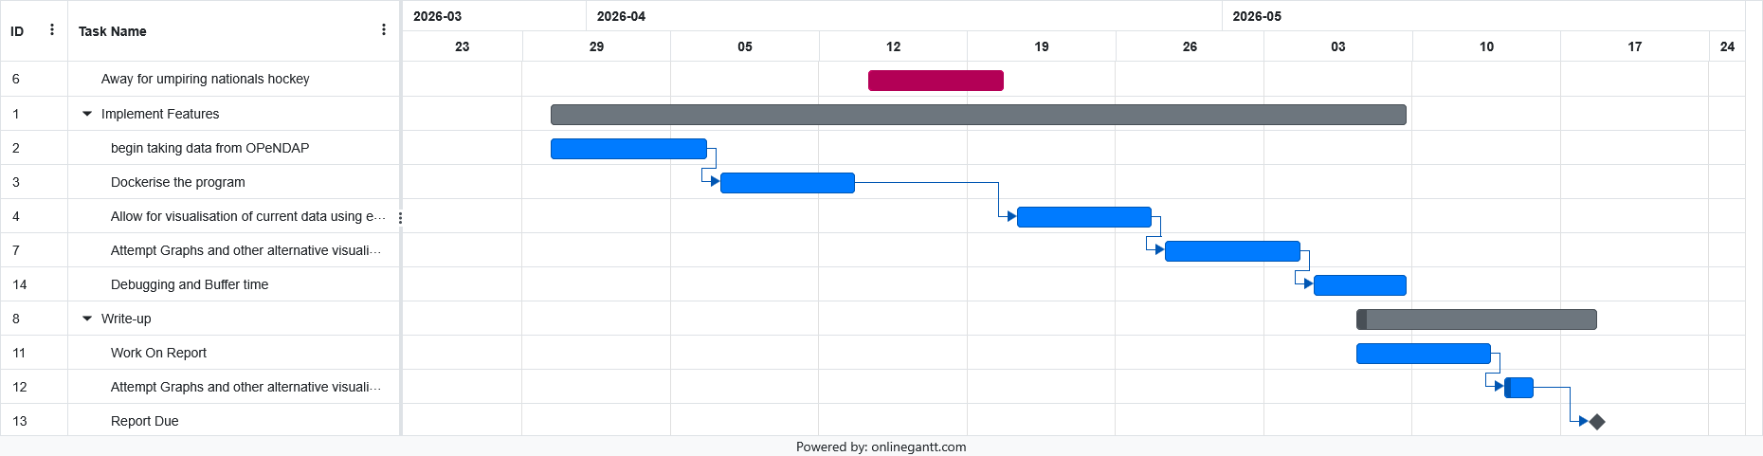
Key:
Blue – Sub-Task
Grey – Overall Task
Red – Time Absent/Not Working on Project

Key:
Blue – Sub-Task
Grey – Overall Task
Red – Time Absent/Not Working on Project

Key:
Blue – Sub-Task
Grey – Overall Task
Red – Time Absent/Not Working on Project

Key:
Blue – Sub-Task
Grey – Overall Task
Red – Time Absent/Not Working on Project

Key:
Blue – Sub-Task
Grey – Overall Task
Red – Time Absent/Not Working on Project

Key:
Blue – Sub-Task
Grey – Overall Task
Red – Time Absent/Not Working on Project

Key:
Blue – Sub-Task
Grey – Overall Task
Red – Time Absent/Not Working on Project

